Nosql Database EXP : 2

output:

Login to Lab

• Show all Databases

• Select database to work with

• Authenticate and Log out from databases

• List down Collections, Users, Roles

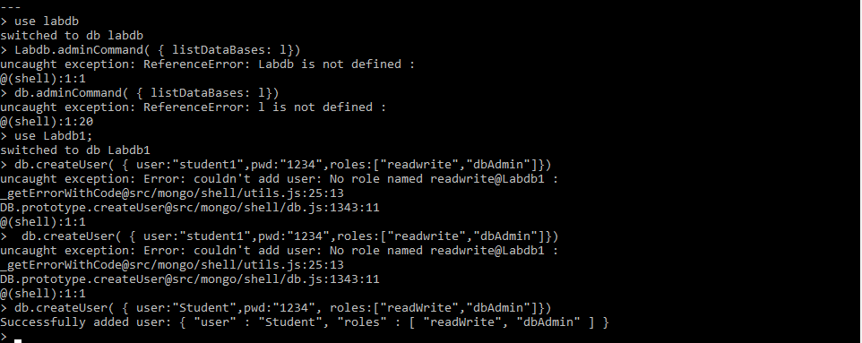Create collection:

Show all Databases

